User Guide: GrabYourGear

User Management

Splash Page
This is the first page of the system. In the page, the system will check if a user has logged in. If a user has logged in, the system will go to the related Dashboard. Otherwise, the system will go to the Login page.
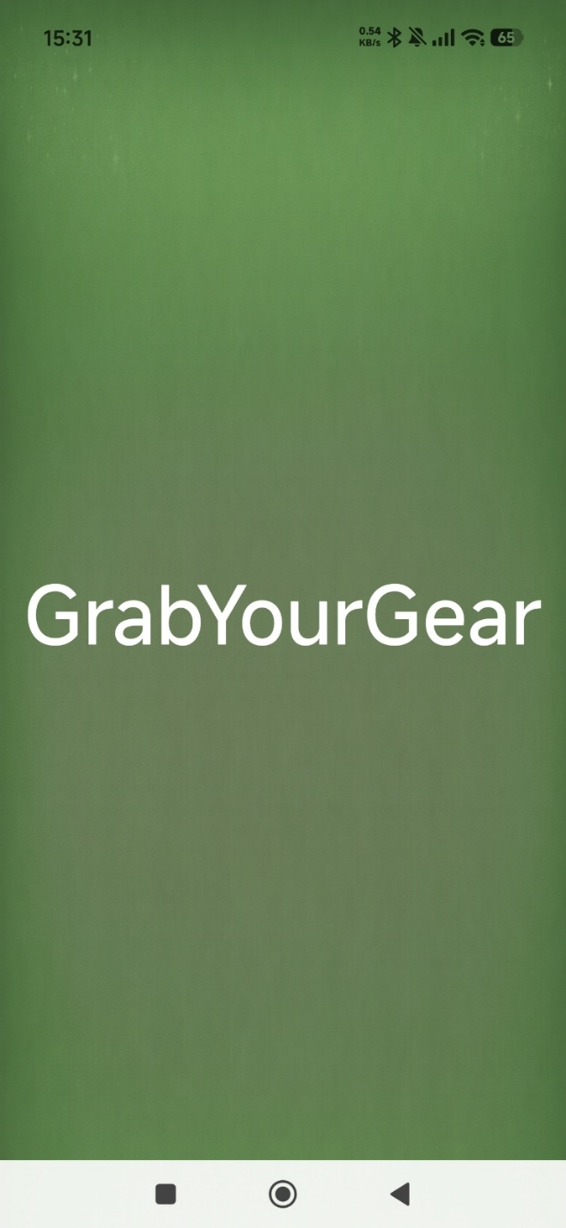

Login Page
There is the Login page. when a user input their account, the system will go to related dashboard. The default admin account is: Amelie@gmail.com/111111
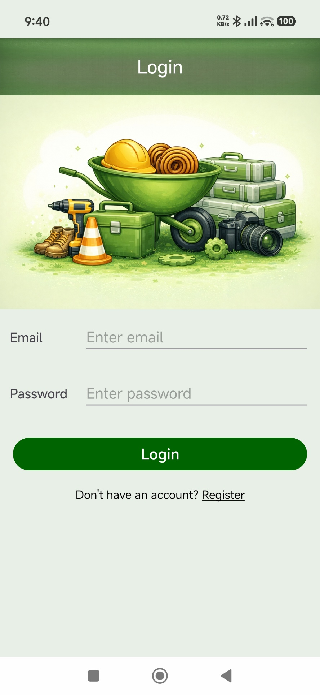

Register Page
The system is open to Customer, Admin, Supplier and Service to register. The new account should input all fields, and the two passwords should match. If a user has an account, they could click the Login link to go to the login page. The Admin, Supplier and Service accounts should be approved by the Admin first.
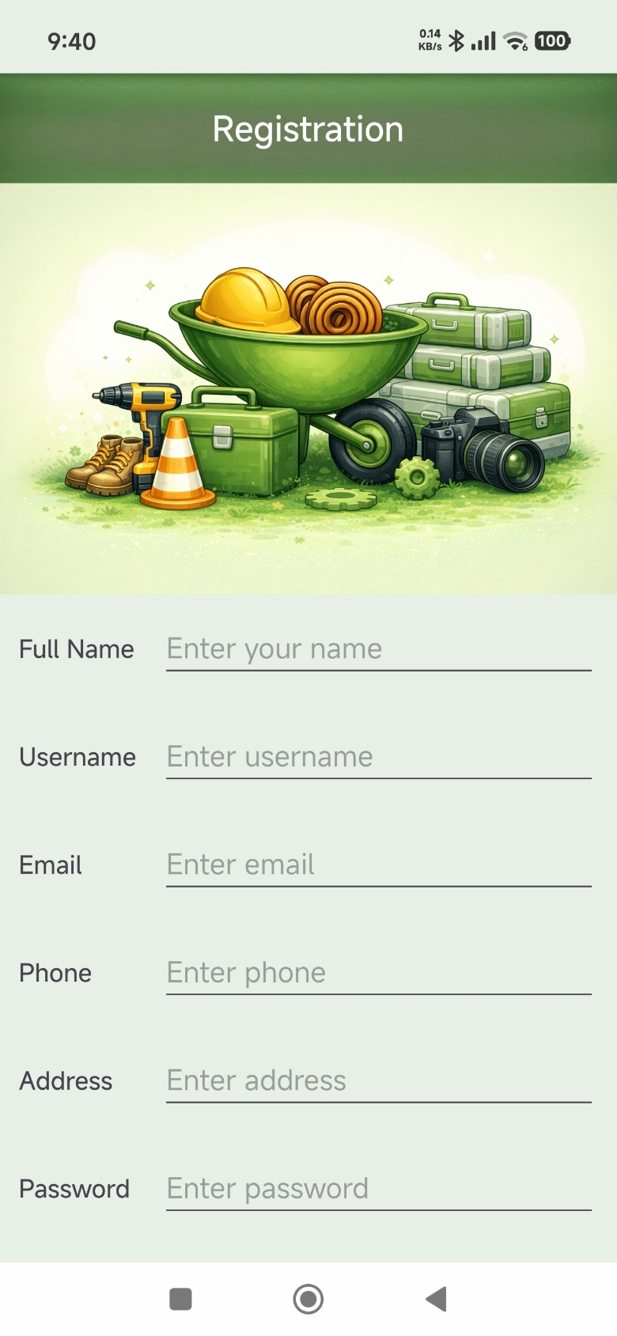

Profile Page
User can view and modify their profile. They can modify all information except Email and Role. The system will check: The old password matches the original password. The two new passwords are the same, and the new password is more than 6 letters. Clicking the Avatar link to select a picture.
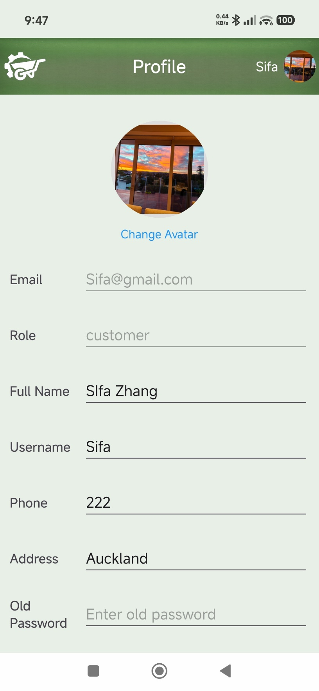

Customer Role

Customer Dashboard
This is the Customer Dashboard. There are four sections:
Title bar: Clicking the Logo back to Dashboard. Clicking the Avatar to show a menu.
Search bar: Input a keyword, the system will filter keywords in the name or description field.
Category quick link: Clicking any one of them to filter items by Category.
Featured Deal List: It shows all items has more than 20% discount and it is available.
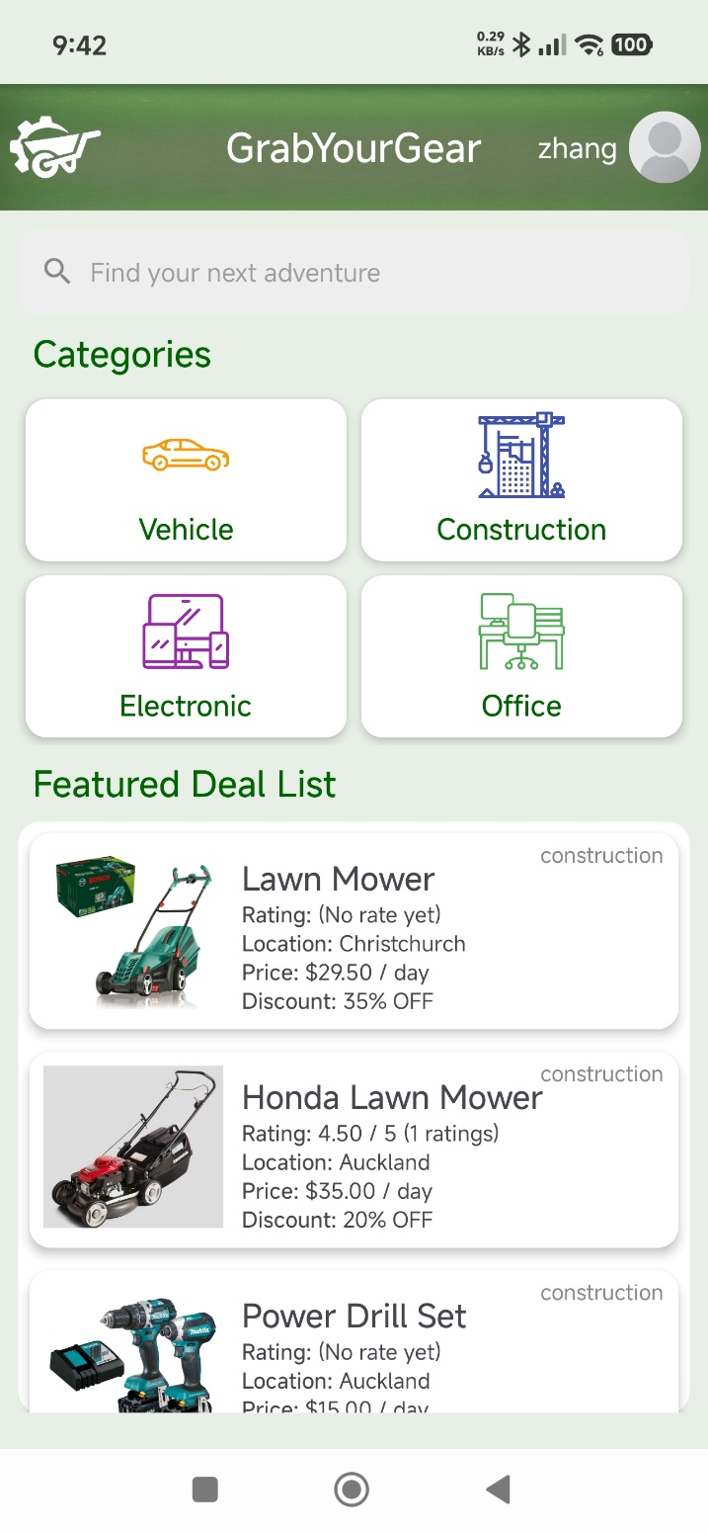

Customer Search by Category
The page shows items from a special category. It comes from the Dashboard by clicking on one category.
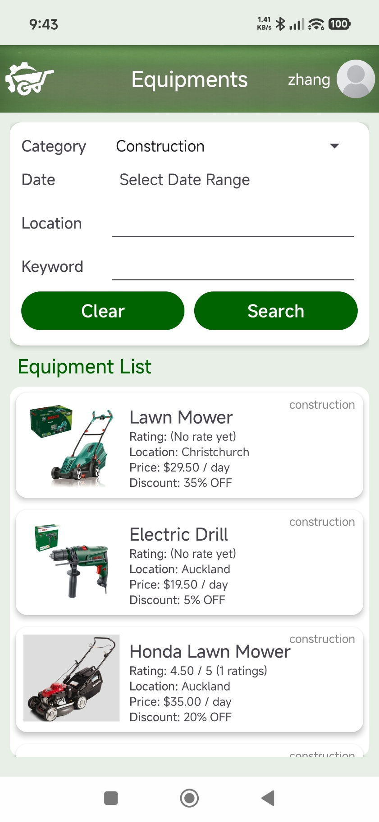

Customer Search by Keyword
The page shows items from a special keyword. They are filtered in name and description. It comes from the Dashboard by inputting a keyword.
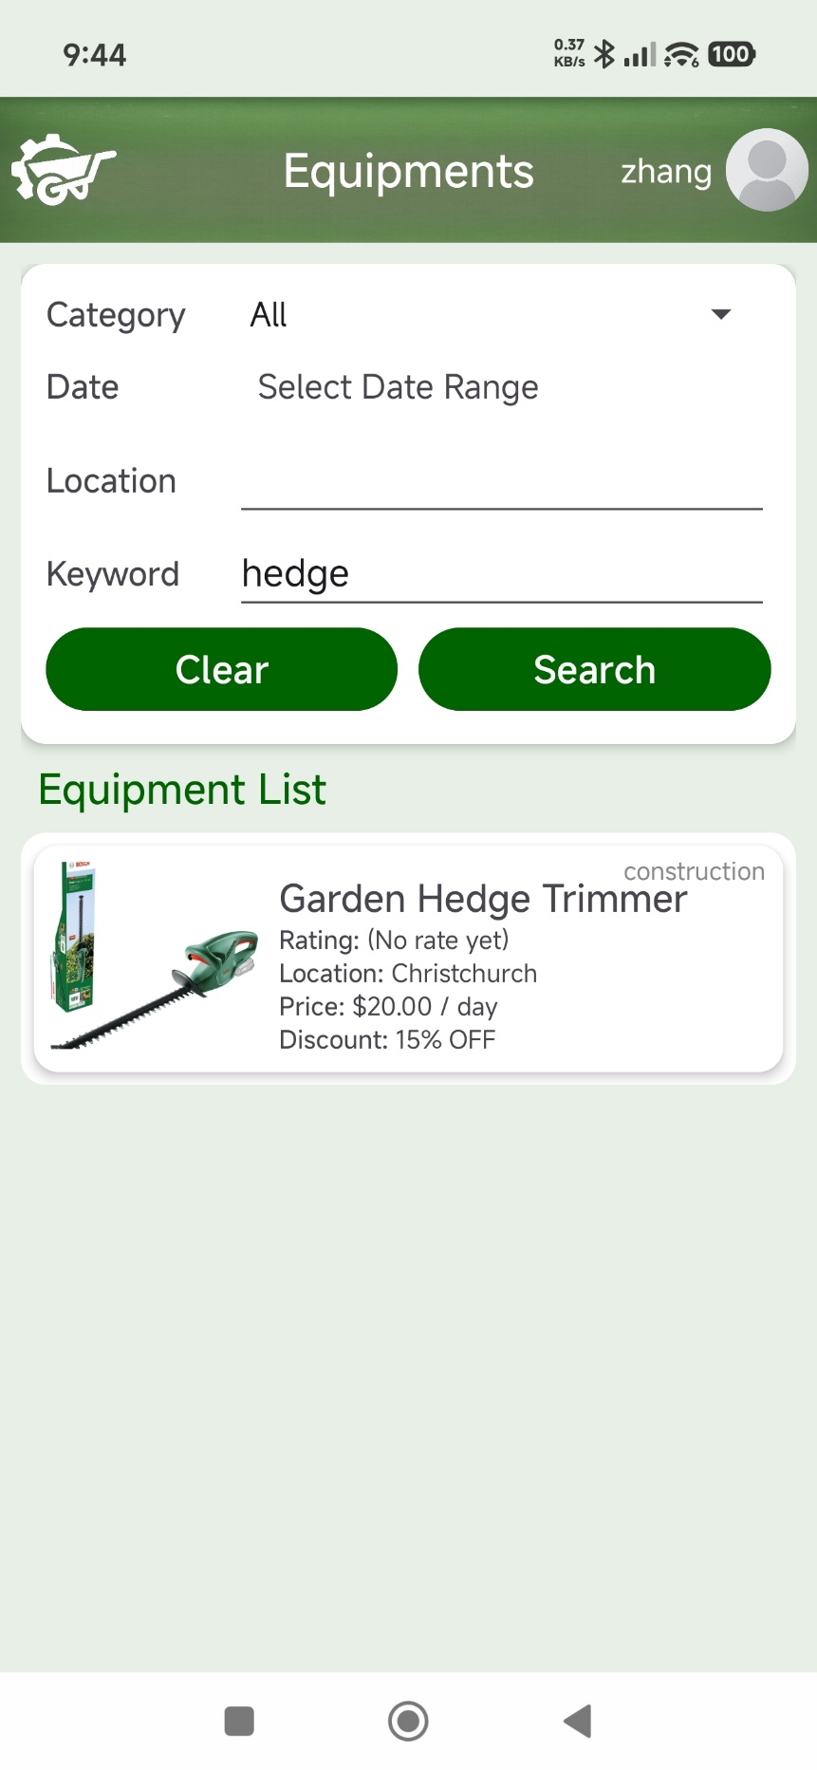

Customer Views Equipment Detail
This page shows all information about the equipment. Clicking the Book button to select a date range.
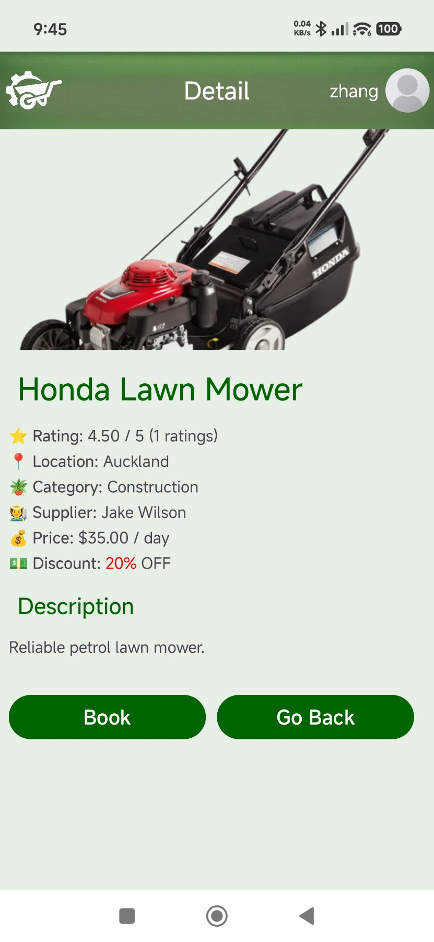

Customer Booking
The page shows the date range selected by a user, and the system will calculate the total price and days automatically. Clicking the Booking Now to select the data range.
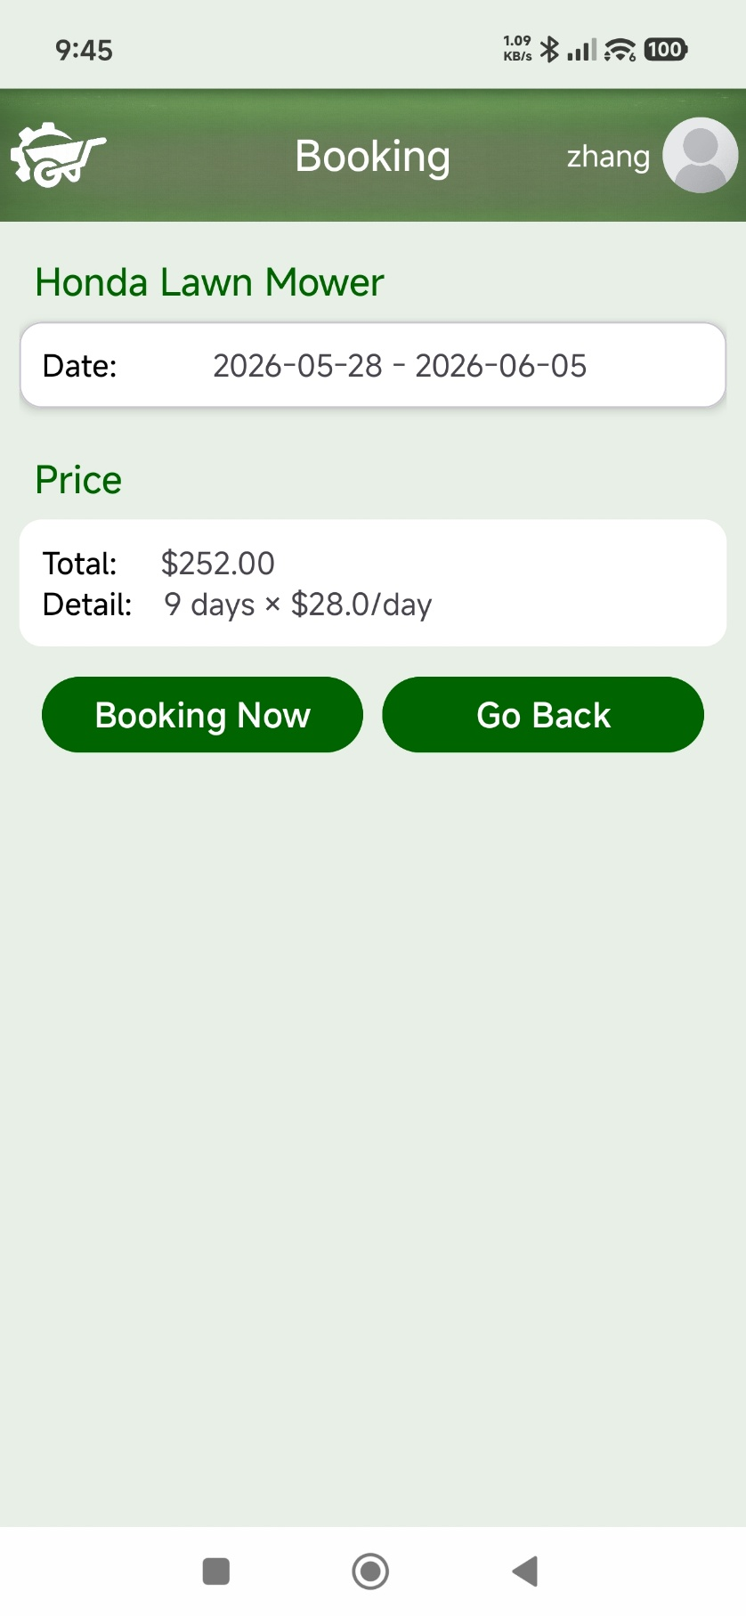

Customer Select Date Range for Booking
This page shows all available dates for the equipment. All unavailable dates will be disabled.
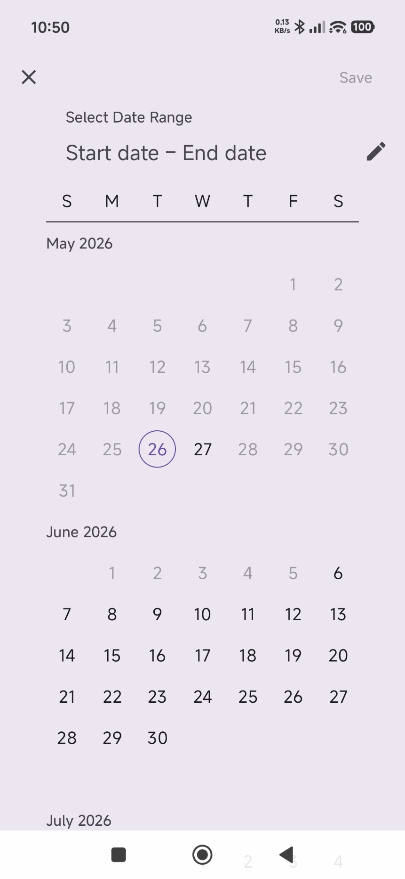

Customer’s Dropdown Menu
Clicking the avatar to show a dropdown menu. A customer can go to their profile, My Bookings Page or Logout from the menu.
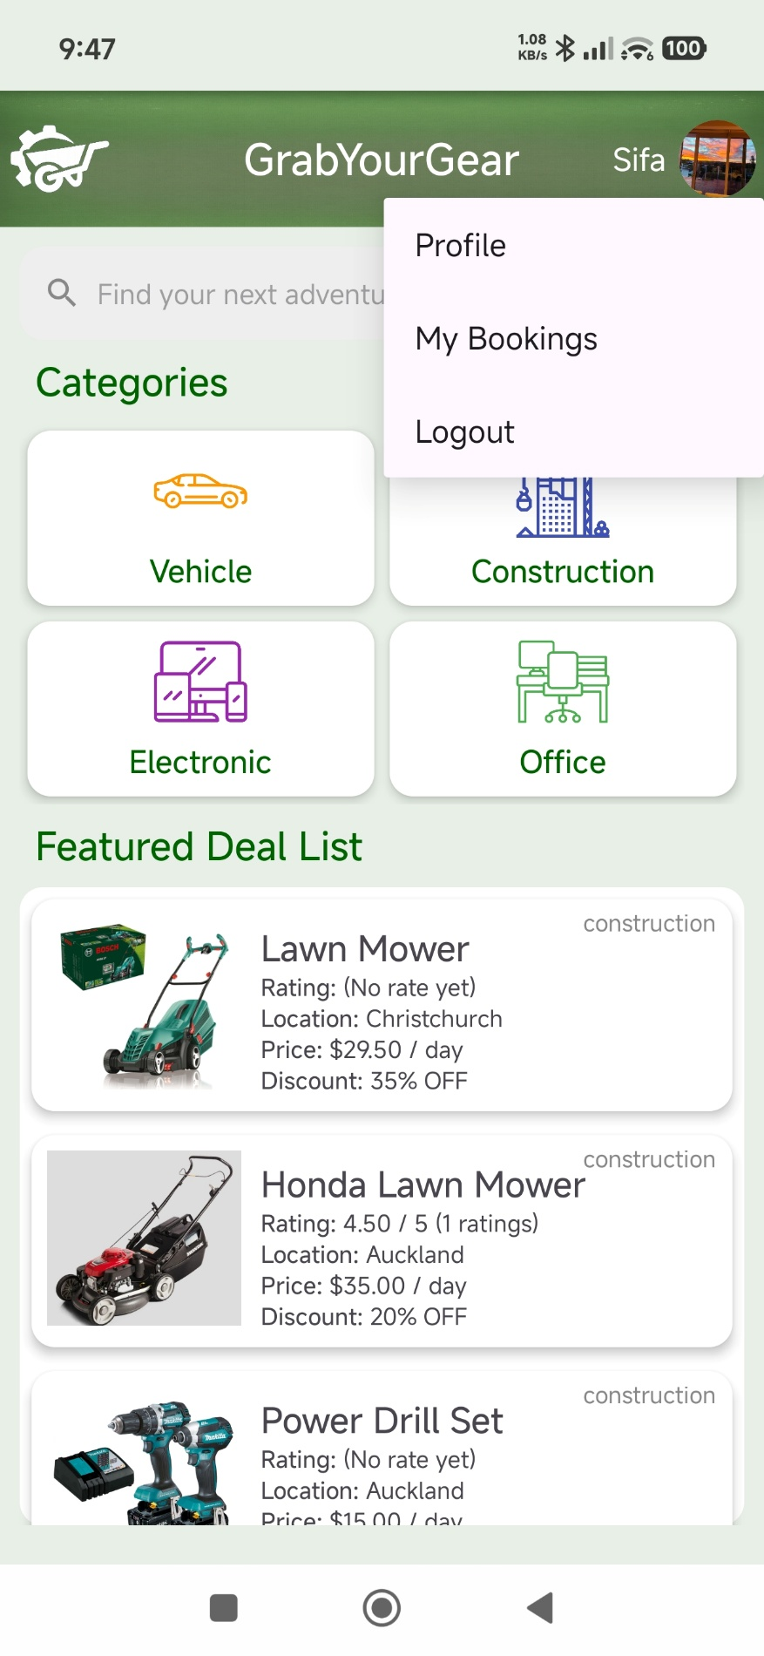

My Bookings page
This page shows all items ordered by the customer.
If a rent has finished, a Rate button will show on the right of the card, while it will disappear when the customer has rated the rent.
If a rent has not been approved, a Cancel button will show on the right of the card, while it will disappear when the customer has cancelled or the rent has been approved.
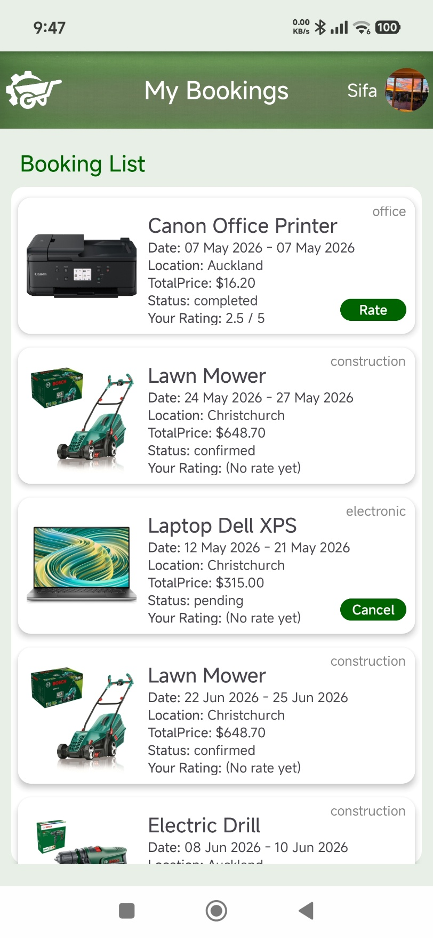

Rating a Equipment
The minimal score is 0.5. After submitting the rating, the system will calculate the rating count and the average score, which will show on the card.
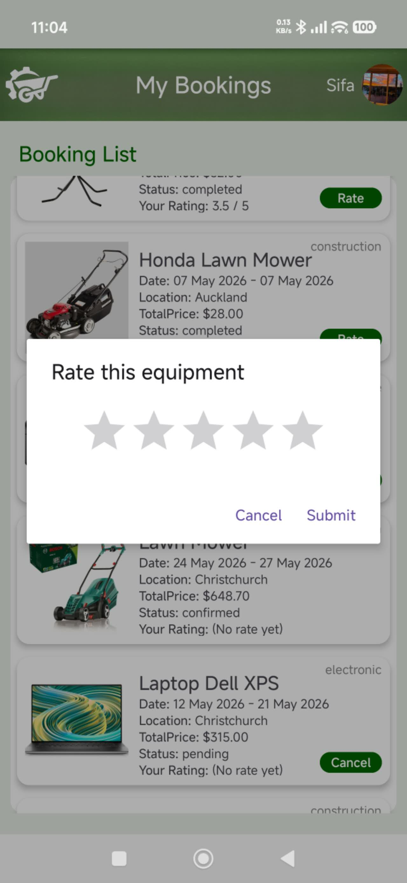

Supplier Role

Supplier Dashboard
In the screenshot below you can see the Supplier Dashboard. This dashboard has four available actions:
- Add Equipment: By clicking on this card, the user is redirected to the “Add Equipment” page where he can add a new piece of equipment.
- My Equipment: Once the user clicks on this card, the “My Equipment” page opens showing a list of all equipment added by this supplier.
- Manage Orders: By clicking on this card, the user is redirected to a list view of all orders for his equipment.
- Store Profile: If the user clicks on this card, he is redirected to his profile page.
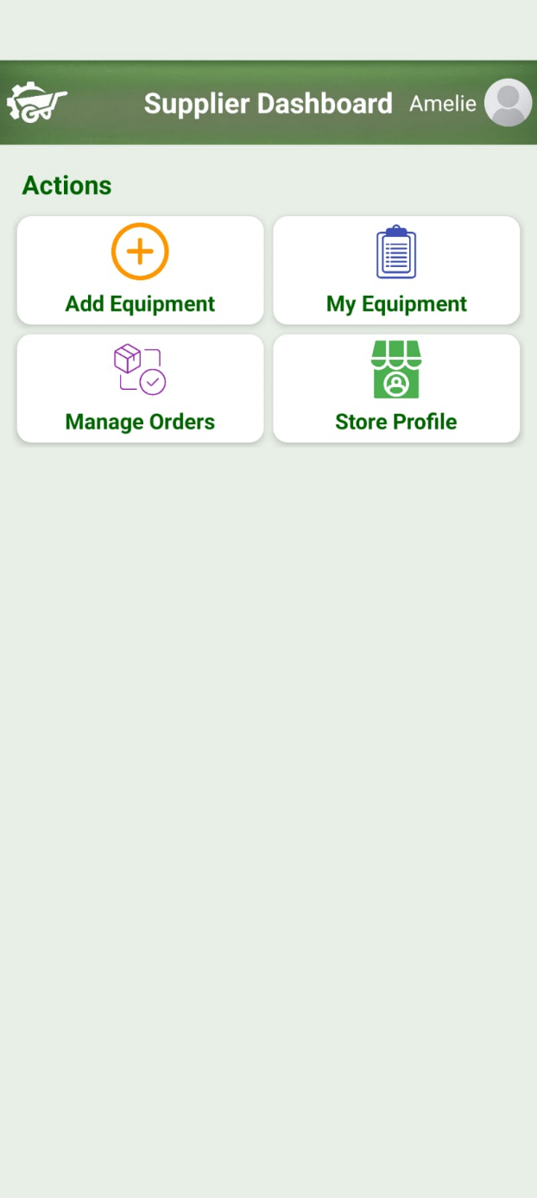

Add Equipment Functionality
The user is redirected to the page below once he clicks on the “Add Equipment” card on the Supplier Dashboard. On this page he can enter all necessary information for the new equipment including name, description, price, discount, location, category and a picture of the product. Afterwards, by clicking on the “Save” button the new piece of equipment is saved and the user is redirected to the supplier dashboard.
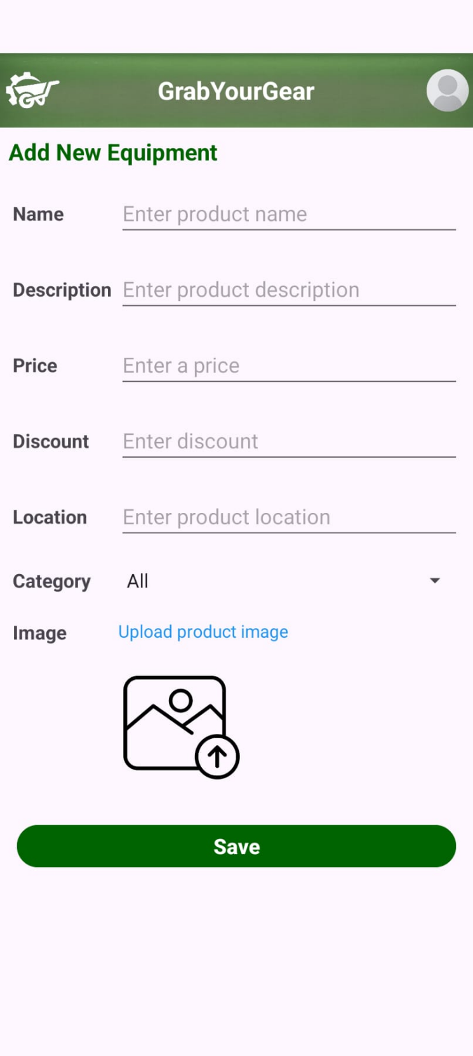

My Equipment Page
Once the user clicks on the “My Equipment” card on the supplier dashboard, he is redirected to this page. At the top of the page the user has the option to filter the list by category, location, status or keyword. By clicking on the “Search” button those filters are applied to the list. If the user clicks on the “Clear” button, all input fields are cleared, and the equipment list shows all pieces of equipment. Each piece of equipment is displayed in individual cards with basic information as well as two buttons directing the user to the “Edit” and “Delete” functionalities.
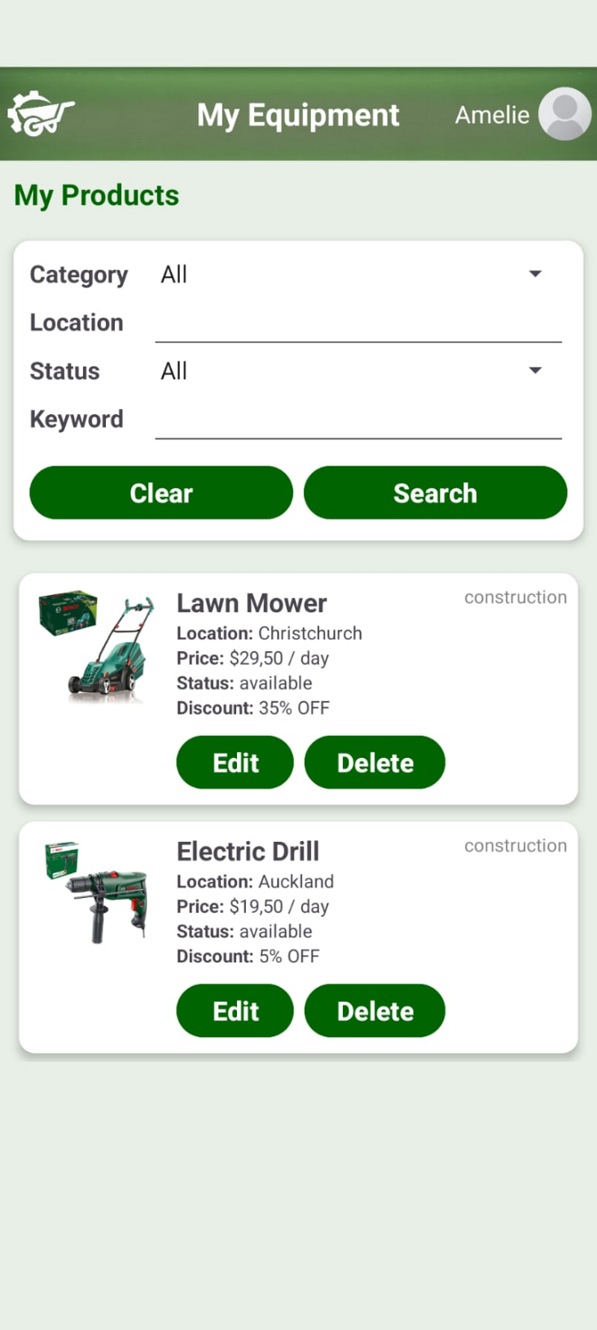

Equipment Detail Page
By clicking on one of the equipment cards displayed in various list pages, the user is redirected to one of the detail pages shown below. If the user clicks on the card from the “My Equipment” list, the detail page would look like the one on the left, showing all the equipment information as well as three buttons for “Edit”, “Delete” and “Go Back”. On the other hand, if the user clicks on an equipment card in the “Manage Orders” list the detail page shown below on the right would be opened. The only difference is that now the buttons displayed change to “Confirm”, “Reject” and “Go Back” giving the user the option to confirm or reject the order.
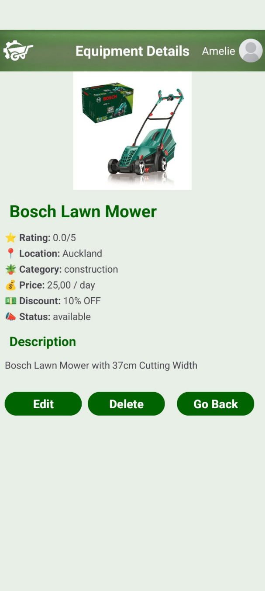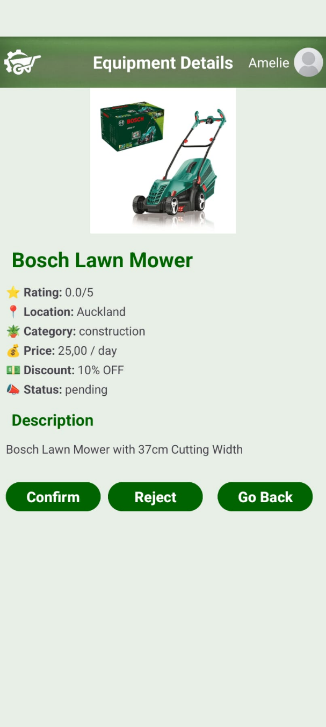

Manage Orders
If the user selects the “Manage Orders” card on the supplier dashboard, he is redirected to this page shown below. At the top of this page, the user can filter the list below by status or keyword. By clicking on the “Search” button, these filters are applied to the equipment list and if the user clicks on the “Clear” button all filter input fields are cleared and the list returns to the original state. In the list all orders are displayed in individual cards. If the supplier has not yet confirmed or rejected the order, he can do so by clicking on the buttons in the card. If he has already made his choice, these buttons are no longer visible in the card.
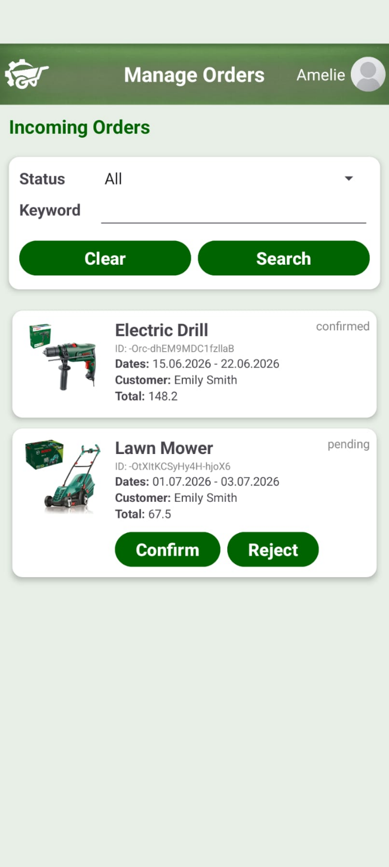

Edit Equipment Functionality
When the user clicks on the “Edit” button either in the “My Equipment” page list or the detail page, he is redirected to this edit page shown below. On this page, the user can change the information for this piece of equipment and save the changes by clicking on the “Save Changes” button at the bottom of the page.
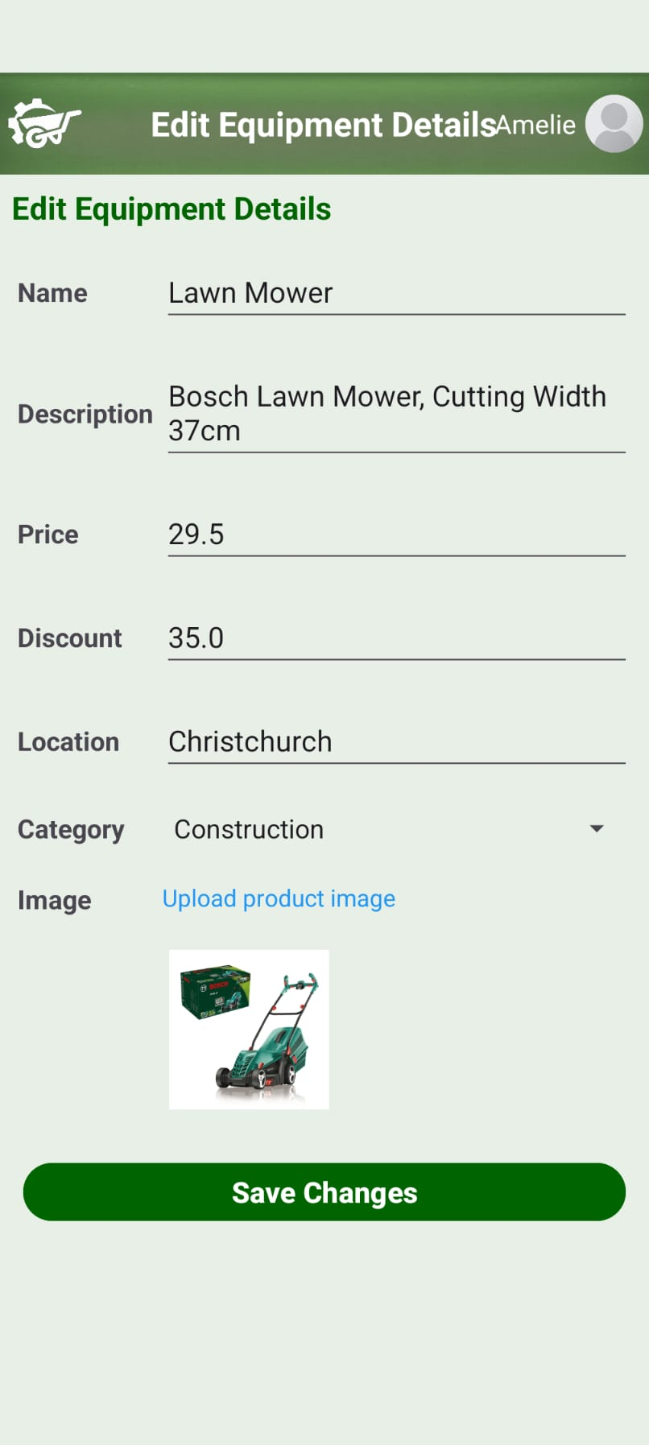

Delete Equipment Functionality
If the user wants to delete a piece of equipment, he can do so either by clicking on the “Delete” button on the individual equipment cards in the “My Equipment” list or by clicking on the “Delete” button on the equipment detail page. In both cases a dialog pops up, where the user can either confirm that he wants to delete or cancel the process.
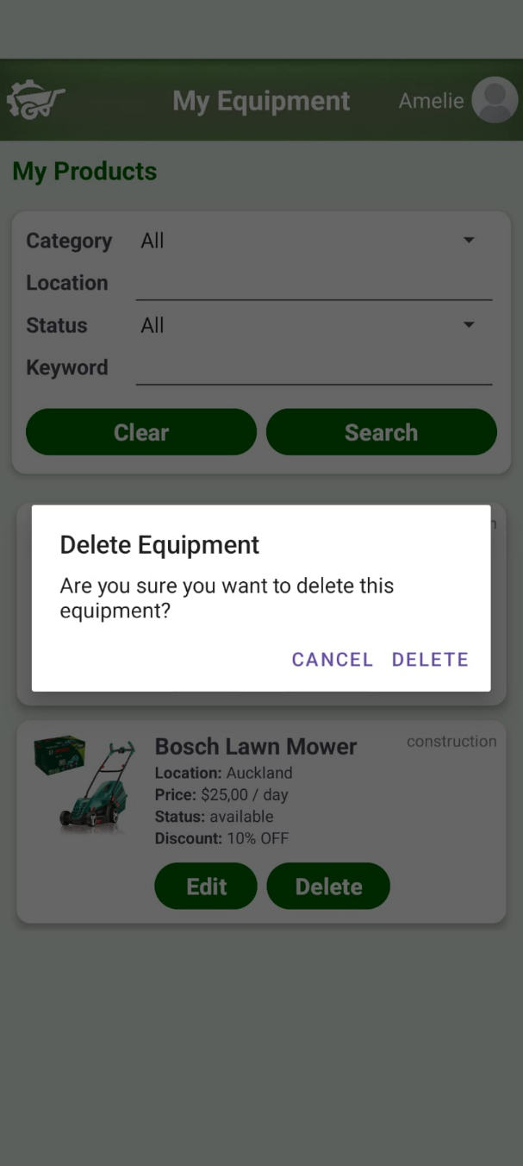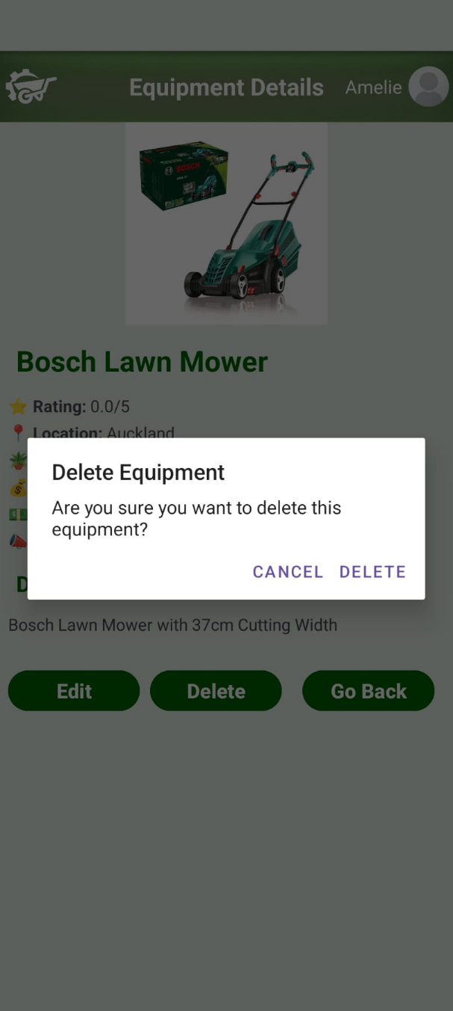

Store Profile
By clicking on the “Store Profile” card on the supplier dashboard, the user is redirected to the profile page, already described previously in the chapter “1.4 Profile Page”.
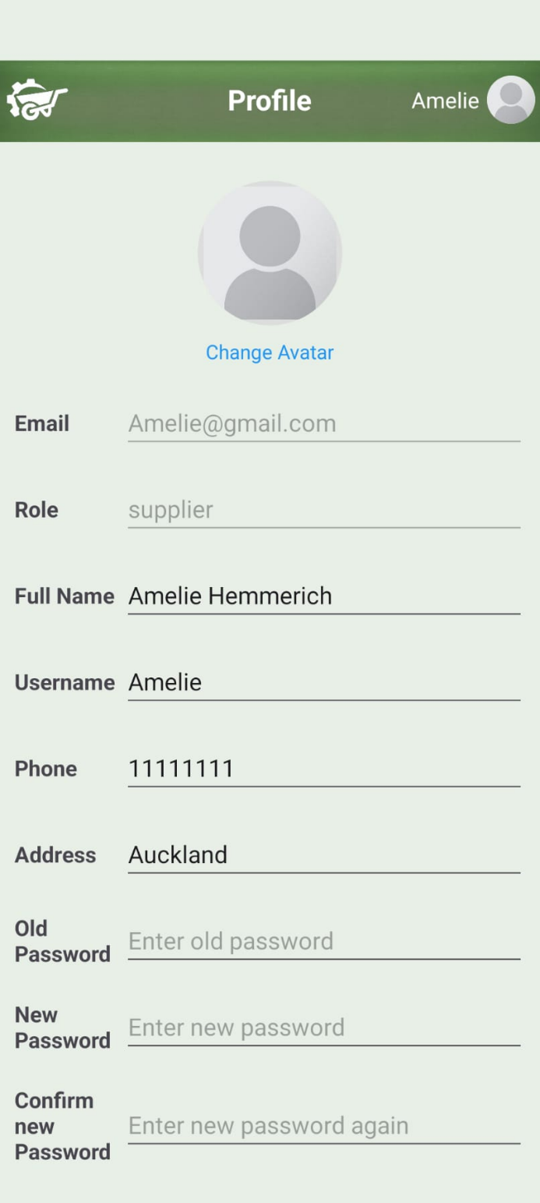

Administrator Role

Administrator Dashboard
The administrator dashboard contains three buttons leading to an activity as well as a counter of the number of unapproved supplier applications, the buttons lead to the following screens:
- View Supplier Applications: This leads to a list of suppliers that are currently not approved where the admin can choose to approve or deny the listed applications.
- Manage Users: Brings the administrator to a list of non-supplier user accounts, from there users can have certain details edited through another activity and user accounts can be banned or unbanned.
- Manage Suppliers: A list of supplier accounts that can be edited or banned, banned suppliers will appear in the applications list mentioned above.
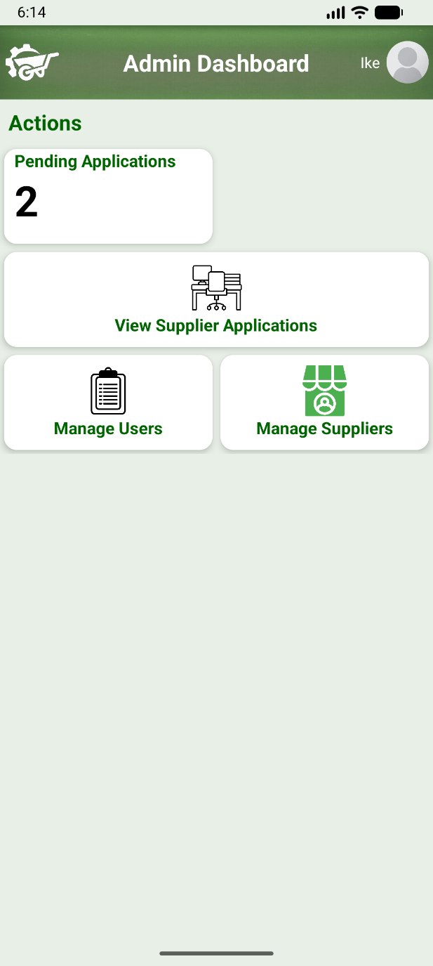

View Supplier Applications
As shown in the screenshot below, this brings up a list of suppliers with buttons to approve or deny the supplier’s application. When a supplier account is first created, it must be approved through this screen before the supplier can log in and access their dashboard. Approving a supplier will remove their application from this list and allow them to log in, denying a supplier’s application will remove their application from the list temporarily until this screen is accessed again from the dashboard. Before the action is performed, the admin will be prompted with a dialog to confirm their decision.
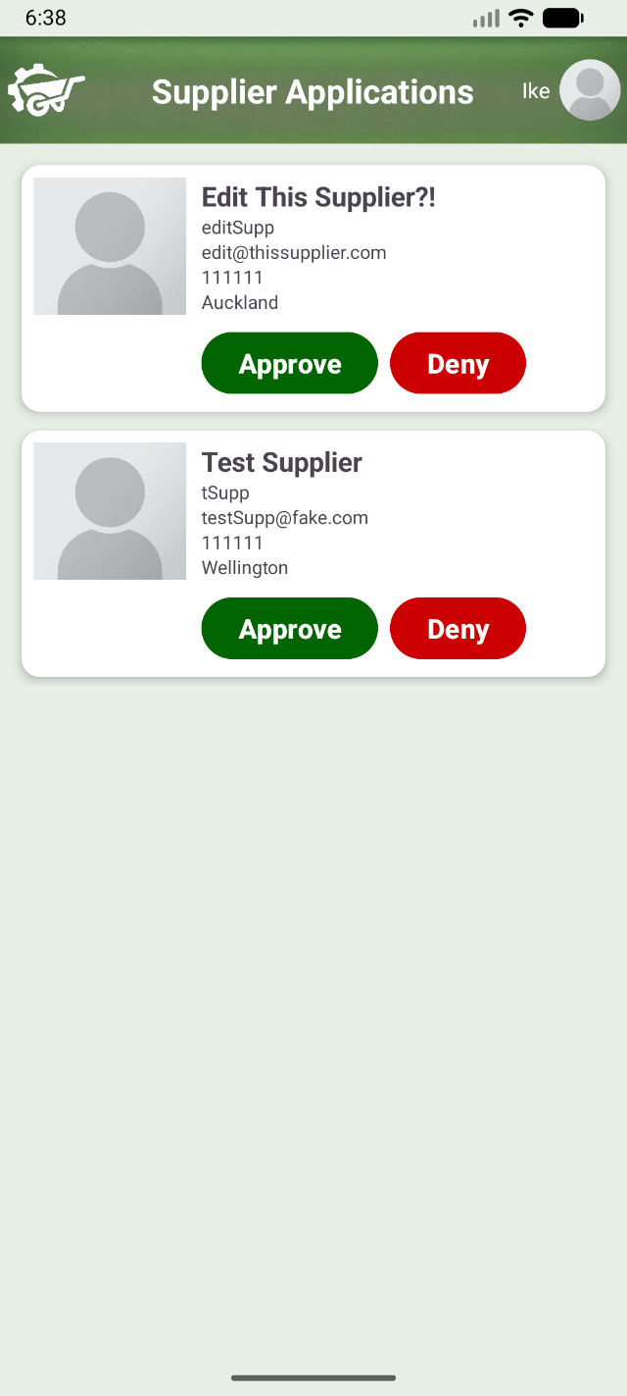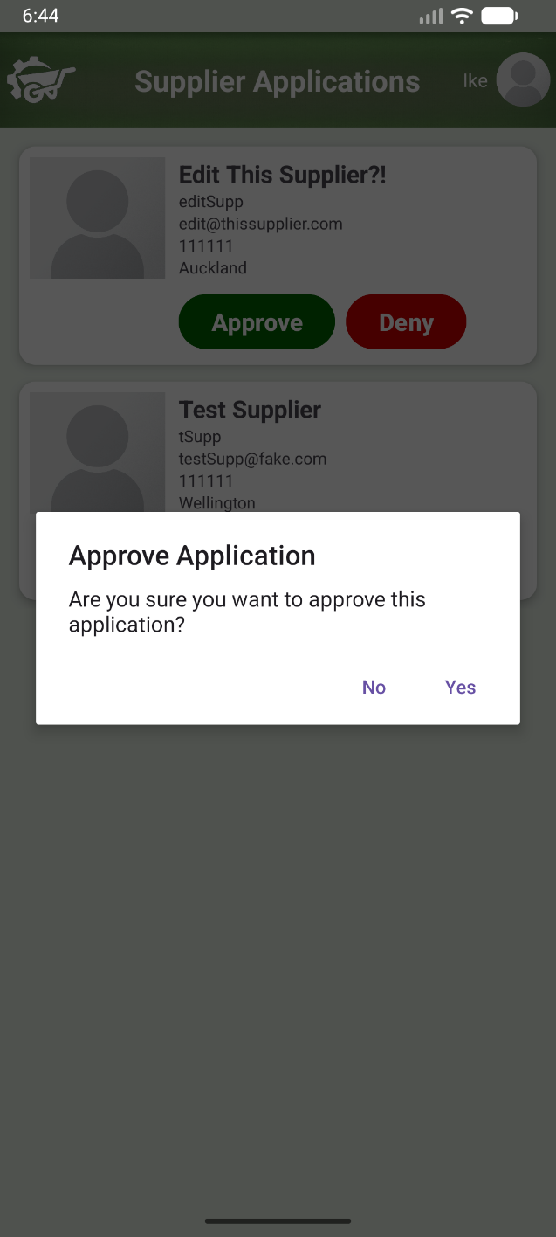

User Management
Simply displays a list of all non-supplier user accounts, each item has a button for going to an edit screen for the chosen user and another button for either banning or unbanning the user. Users that are currently banned will show “Unban” instead of “Ban” on the button that can be seen below.
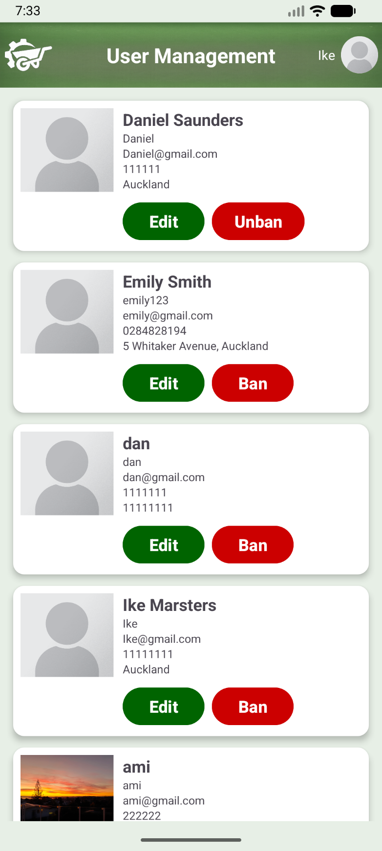

Supplier Management
Displays a list of all approved suppliers with buttons on each supplier item to go to an edit screen or ban the supplier which will set the supplier to being not approved. Suppliers can be approved again through the supplier application management screen detailed in section 4.2.
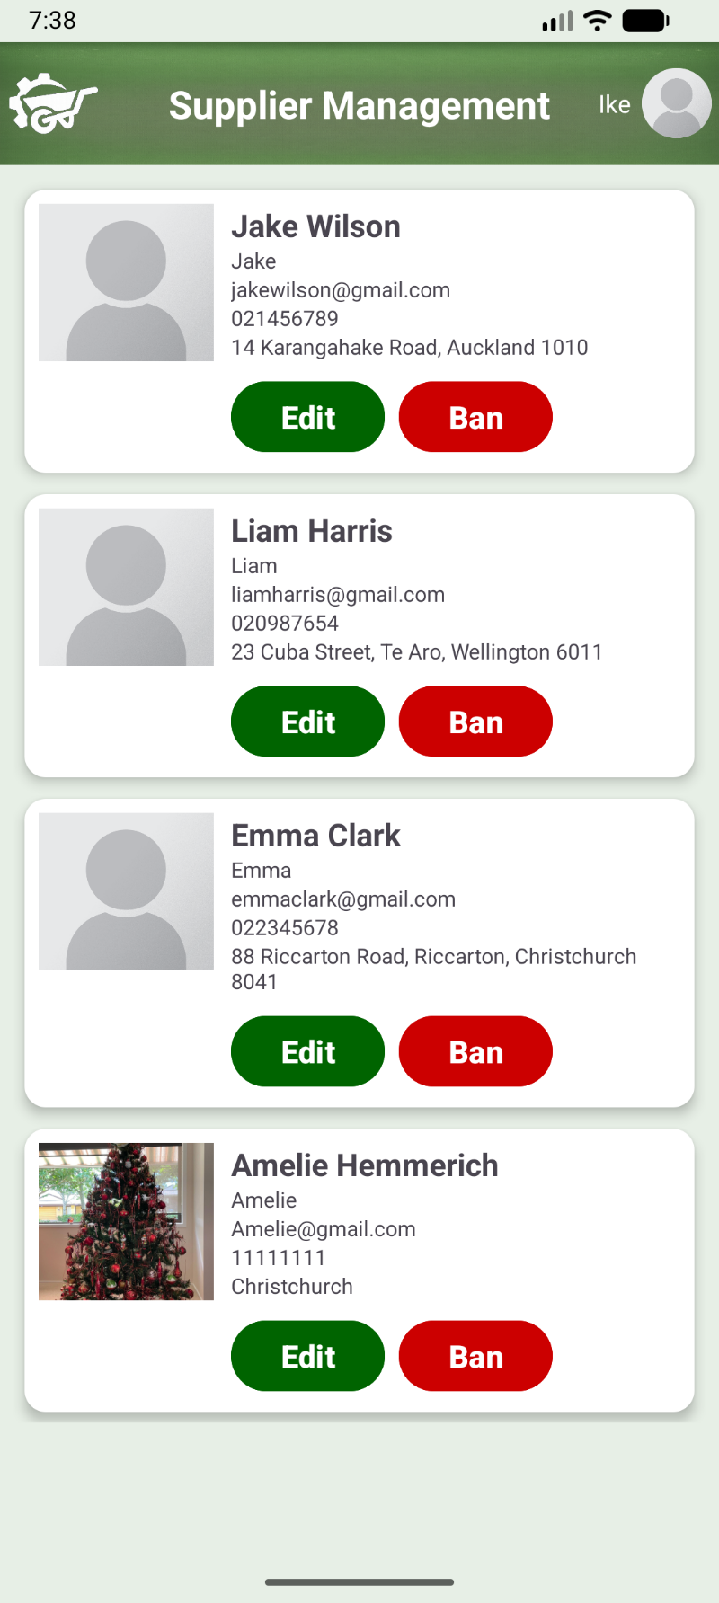

Account Detail Editing
This screen is accessible through both the supplier list and the user list with slight visual differences depending on the user’s role such as a different header. The account details shown on the screen can be edited from here and the admin has buttons to either save the changes or cancel the process.
